Test Data

# Planners account

## Method 1

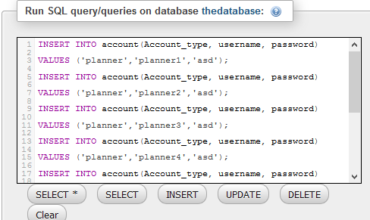

Full Query

INSERT INTO account(Account_type, username, password)

VALUES ('planner','planner1','asd');

INSERT INTO account(Account_type, username, password)

VALUES ('planner','planner2','asd');

INSERT INTO account(Account_type, username, password)

VALUES ('planner','planner3','asd');

INSERT INTO account(Account_type, username, password)

VALUES ('planner','planner4','asd');

INSERT INTO account(Account_type, username, password)

VALUES ('planner','planner5','asd');

INSERT INTO account(Account_type, username, password)

VALUES ('planner','planner6','asd');

## Method 2

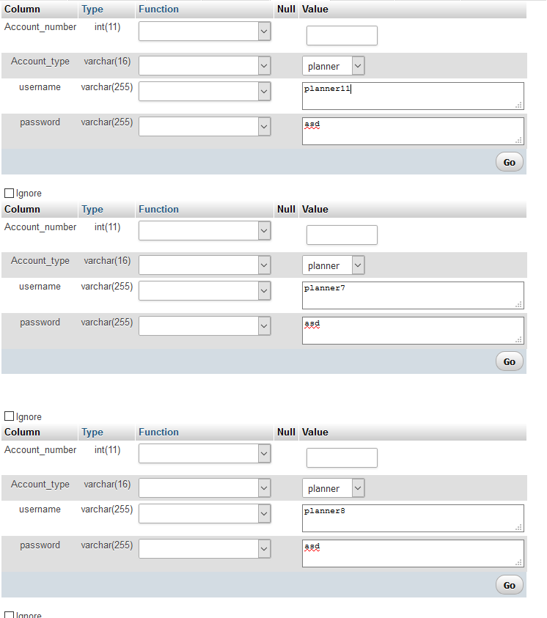

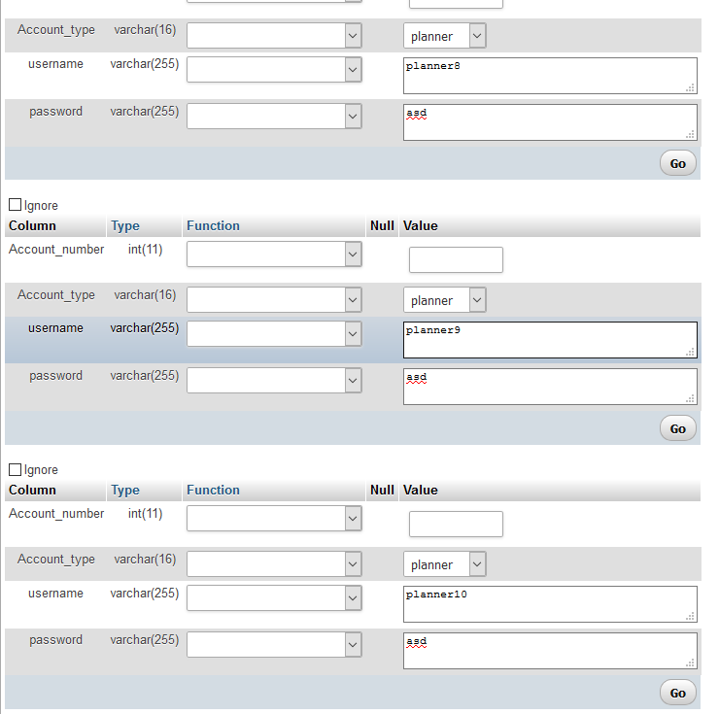

# Finishing planners account details

## Method 1

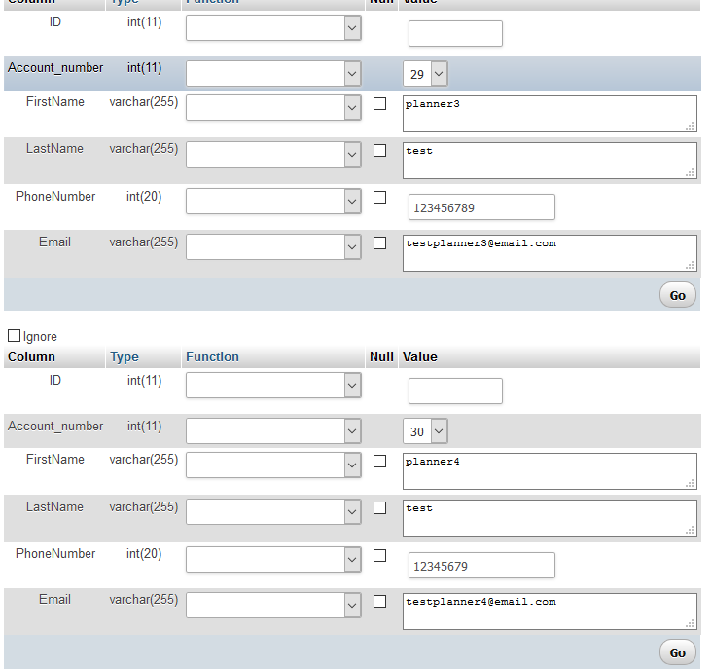

## Method 2

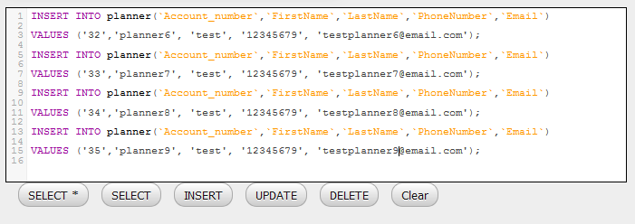

# Volunteer account

## Method 1

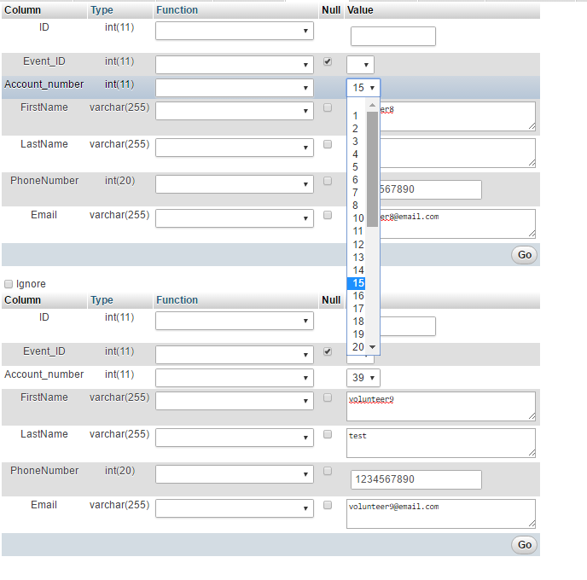

# Events

## Method 1

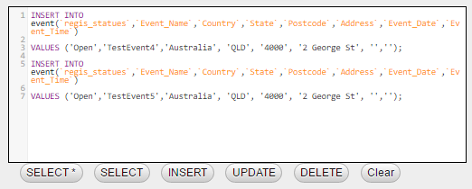

## Method 2

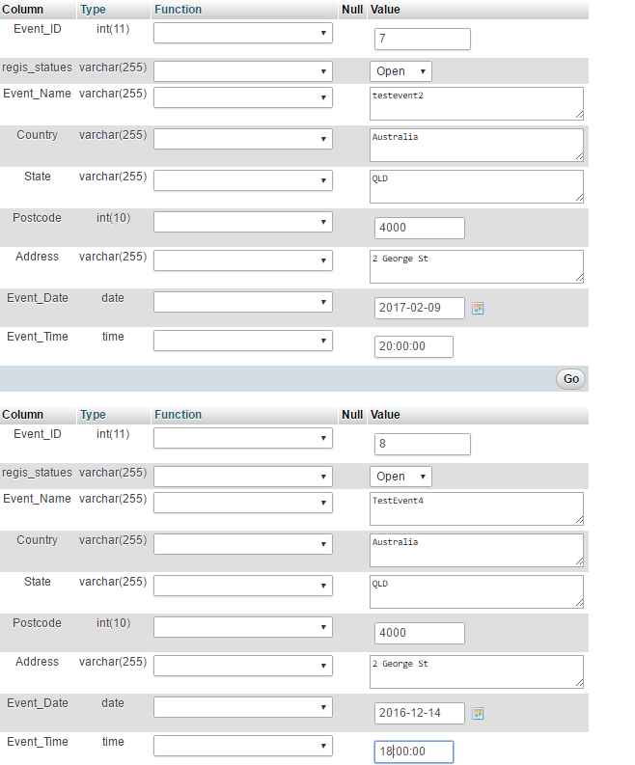

# Event planners

